Practical CI/CD setup to deploy Prometheus + Grafana + Node Exporter on an EC2 instance using Jenkins + Docker Compose

- Architecture Overview

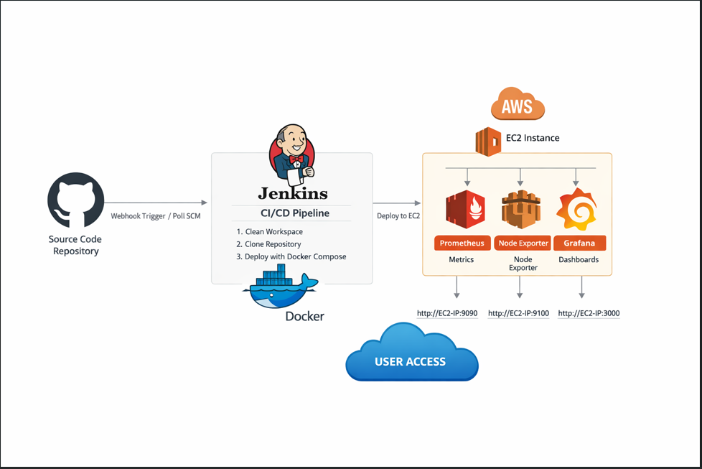
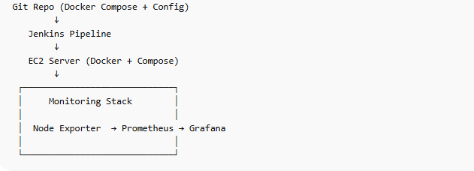

- EC2 Setup (One-time)

Install Docker
sudo apt update
sudo apt install docker.io -y
sudo systemctl enable docker
sudo systemctl start docker
Install Docker Compose
sudo apt install docker-compose -y
Add user to docker group
sudo usermod -aG docker ubuntu
verify:
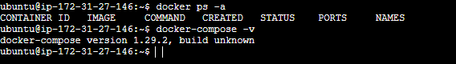

3: Create Project Folder
mkdir monitoring-stack
cd monitoring-stack

STEP 4: Create Docker Compose File
vim docker-compose.yml

version: '3.8'
services:
prometheus:
image: prom/prometheus
container_name: prometheus
volumes:
- ./prometheus.yml:/etc/prometheus/prometheus.yml
ports:
- "9090:9090"
node-exporter:
image: prom/node-exporter
container_name: node-exporter
ports:
- "9100:9100"
grafana:
image: grafana/grafana
container_name: grafana
ports:
- "3000:3000"
Save: CTRL + X → Y → ENTER

⚙️ STEP 5: Create Prometheus Config
vim prometheus.yml

global:
scrape_interval: 15s
scrape_configs:
- job_name: 'node-exporter'
static_configs:
- targets: ['node-exporter:9100']

▶️ STEP 6: Run Monitoring Stack
docker-compose up -d
Check:
docker ps

Prometheus UI:
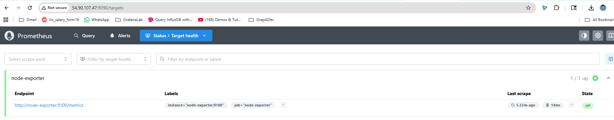
Grafana UI:
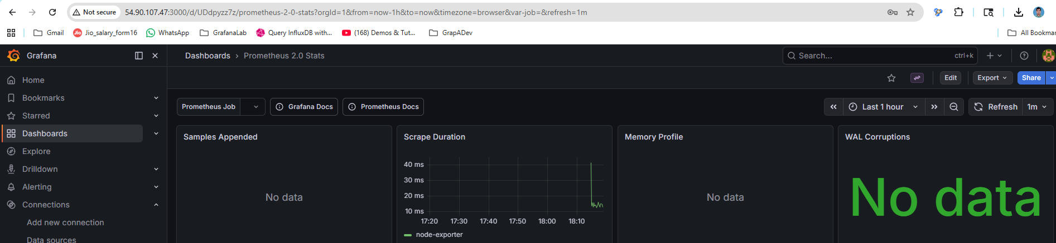

STEP 11: Install Jenkins (on SAME EC2)
Add Jenkins key (NEW WAY – REQUIRED)

STEP 1: Import missing key directly
sudo gpg --keyserver keyserver.ubuntu.com \
--recv-keys 7198F4B714ABFC68

📥 STEP 2: Export it to keyring
sudo gpg --export 7198F4B714ABFC68 | \
sudo tee /usr/share/keyrings/jenkins-old.gpg > /dev/null

🔗 STEP 3: Update repo to use BOTH keys
echo "deb [signed-by=/usr/share/keyrings/jenkins-keyring.gpg,/usr/share/keyrings/jenkins-old.gpg] https://pkg.jenkins.io/debian-stable binary/" | \
sudo tee /etc/apt/sources.list.d/jenkins.list
sudo apt install jenkins -y

Start Jenkins:
sudo systemctl start jenkins
sudo systemctl enable Jenkins
Open Jenkins
http://EC2-IP:8080
Get password:
sudo cat /var/lib/jenkins/secrets/initialAdminPassword
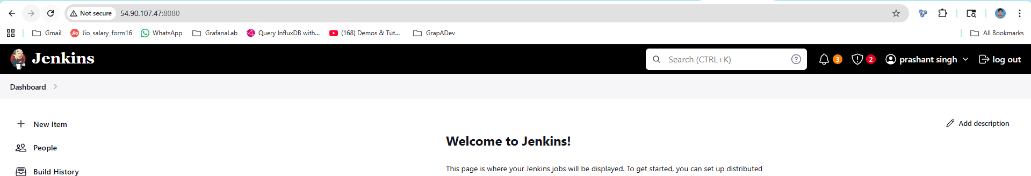

Push Code to GitHub
git init
git add .
git commit -m "monitoring setup"
Create GitHub repo → then:

git remote add origin https://github.com/prashantnitt07/Proemtheus-deploy-with-Jenkins.git
git branch -M main
git push -u origin main

configure item and pipeline

pipeline {
agent any

stages {

stage('Clean Workspace') {
steps {
deleteDir()
}
}

stage('Clone Repo') {
steps {
git branch: 'main', url: 'https://github.com/prashantnitt07/Proemtheus-deploy-with-Jenkins.git'
}
}

stage('Deploy') {
steps {
sh '''
echo "Current directory:"
pwd
ls -l

docker-compose down || true
docker-compose up -d

docker ps
'''
}
}
}

}

Console output 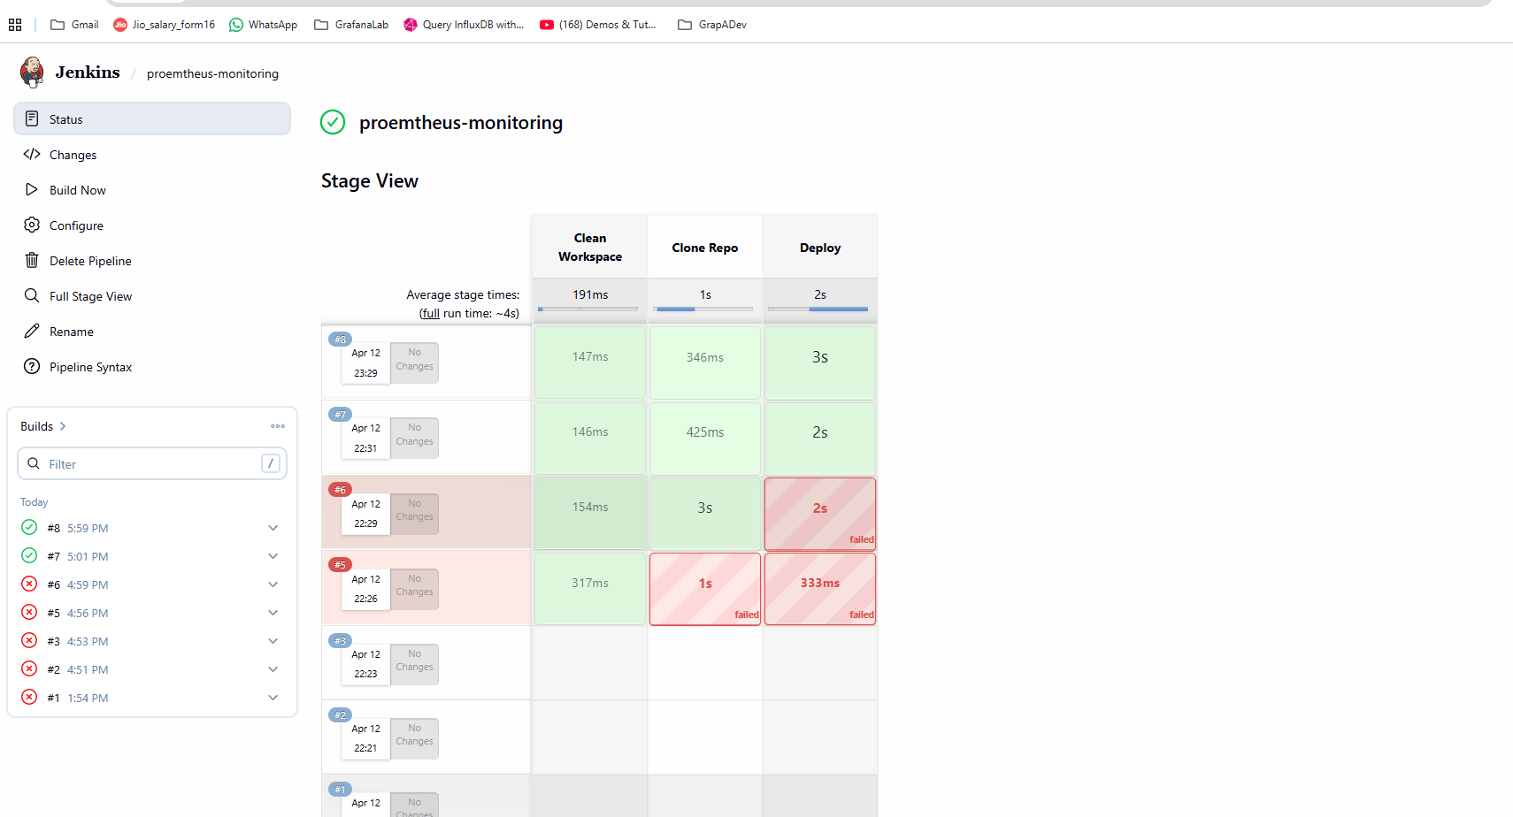

URL detail :
Prometheus
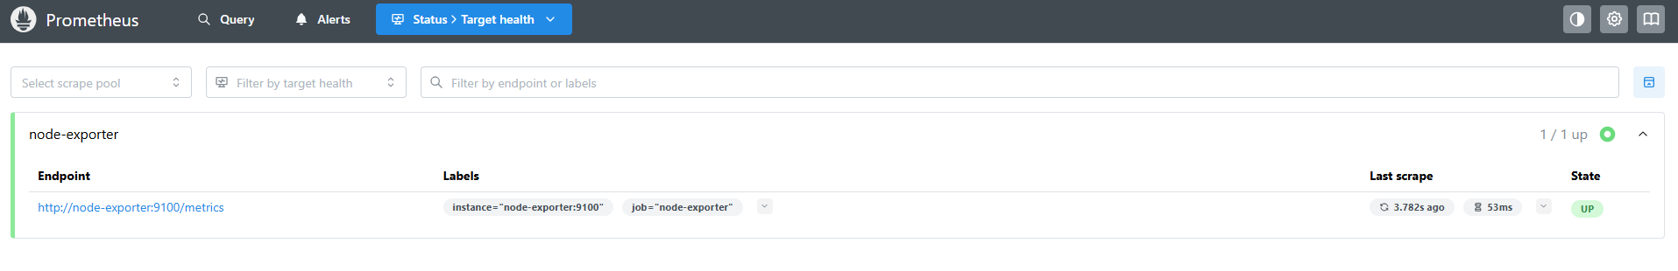

Grafana:
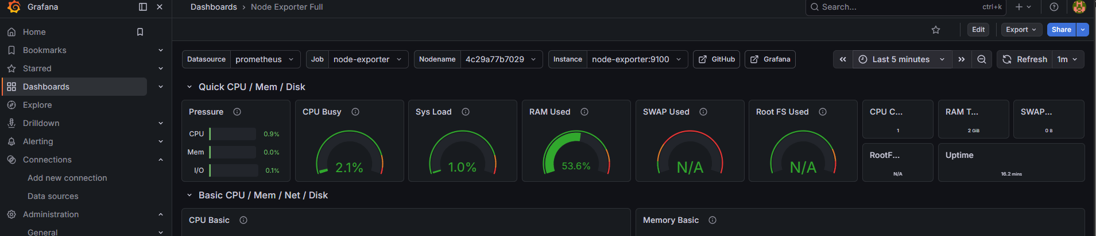

Extra setting required when you create Pull request , code automatically push to EC2 or target”

Github setting :

- Go to your repo on GitHub
Example: https://github.com/<your-username>/<repo>
- Click Settings (top menu of repo)
- In left sidebar → click Webhooks
- Click Add webhook

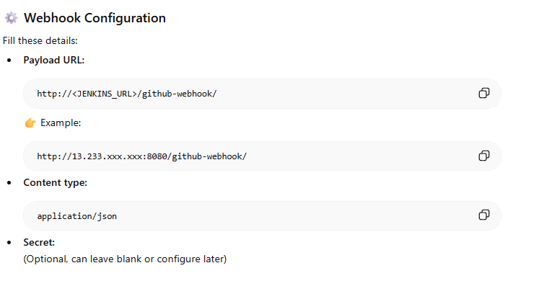

Jenkins Side (Important)
Make sure Jenkins is also ready:
- Install plugin:
  - GitHub Integration Plugin
- In your pipeline job:
  - Enable:
✅ GitHub hook trigger for GITScm polling

